# Christmas Cheer Laser, part 7

## Answer to the Previous Question

1. What is the next riddle? Note the part of this riddle, “then you /shall/see .”  
   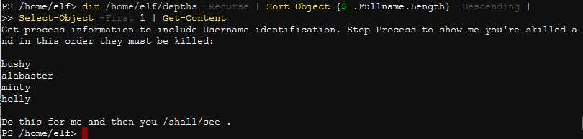  
   ~~Get-Process -username~~  
   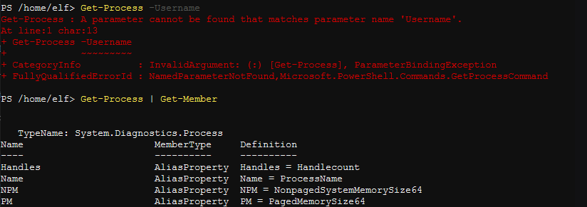  
   Hmm, Username is not valid. Time for the search engine. <https://thinkpowershell.com/get-process-name-and-owner-user-name/> tells us to use -IncludeUserName.  
   Get-Process -IncludeUserName  
   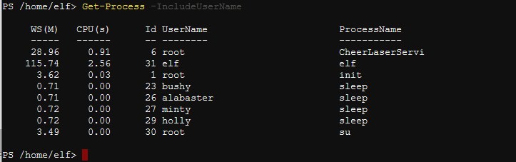  
   We just need to kill the processes in order, bushy, alabaster, minty, and holly. It turns out you don’t even have to write a script, doing it by hand works.  
   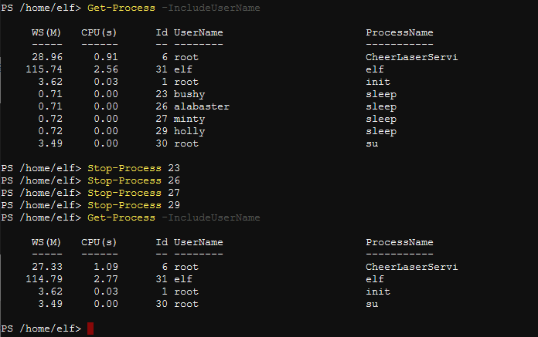  
   The hint, “then you /shall/see .” was telling us to get the content of /shall/see.  
   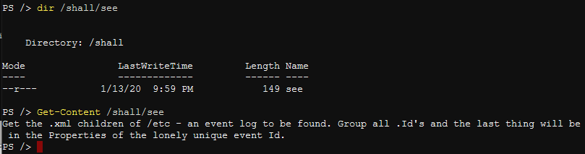

Wow, another riddle. Does this ever stop?

The .xml file you will find is very long, as each event has about 200 lines and there are 1200 events. You may use XML commands, write a script or just take a shot at searching for something you know should be in the file.

Note: It looks strange, but if you are searching for text files, dir /folder/*.txt works well.

Question

1. What laser parameters do you recover from the XML document?